Invulblad SO skelet niveau 3 &4 Naam: Klas:

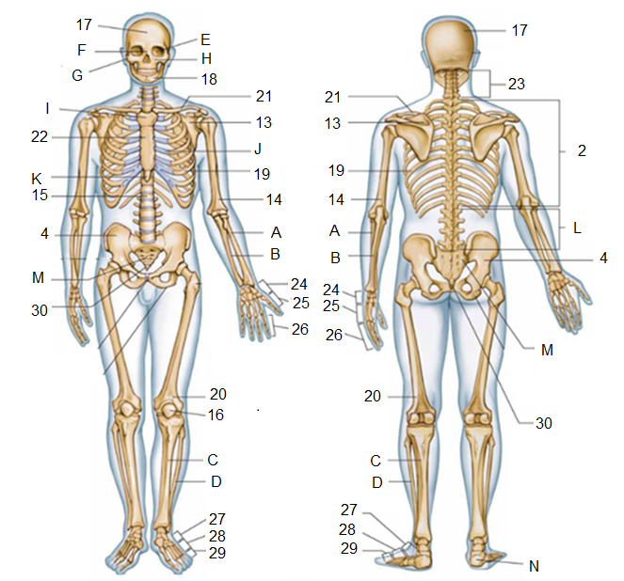

Niveau 3

|  |  |  |  |  |
| --- | --- | --- | --- | --- |
| 21 |  |  | 26 |  |
| 22 |  |  | 27 |  |
| 23 |  |  | 28 |  |
| 24 |  |  | 29 |  |
| 25 |  |  | 30 |  |

Niveau 4

|  |  |  |  |  |
| --- | --- | --- | --- | --- |
| E |  |  | J |  |
| F |  |  | K |  |
| G |  |  | L |  |
| H |  |  | M |  |
| I |  |  | N |  |